|  |
| --- |
| User Manual  Samuda Inventory |
| REFERENCE: GW/ERP/USER MANUAL |
|  |
| **Genweb2 Ltd.** |
| **13-Aug-20** |



|  |
| --- |
|  |

# 

# Document Information

|  |  |
| --- | --- |
| Document Name | User manual for Inventory |
| Document Author | Rashedul Alam |
| Document Version | 1.3 |
| Release Date | 13th t Aug, 2020 |

|  |  |
| --- | --- |
| 1st & 2nd Review by | Md. Matiar Rahman |
| 1st Review Date | 12th April, 2018 |
| 2nd Review Date | 9th Feb 2020 |
| 3rd Review by | Md. Mahfuzur Rahman |
| 3rd Review Date | 12th Aug, 2020 |
| Approved By |  |
| Approval Date |  |

# Document History

|  |  |  |  |  |  |
| --- | --- | --- | --- | --- | --- |
| A=Added, M=Modified, D=Delete | | | | | |
| **Version No** | **Date** | **Section No** | **A/M/D** | **Description of Change** | **Author** |
| 1.0 | 11-April-2018 |  | A | Initial | Rashedul Alam |
| 1.1 | 17-April-2018 |  | A | Gate in | Rashedul Alam |
| 1.2 | 14-May-2018 |  | A | Configuration | Rashedul Alam |
| 1.3 | 4-Aug-2020 |  | M | New image add & Some text add and modification | Rashedul Alam |

Contents

A. Document Information 2

B. Document History 2

1. Introduction 4

1.1 Purpose of User manual 4

2. Configuration 4

2.1 Create Indent type by Inventory Manager 4

2.2 Create Warehouse by Inventory Manager 5

2.3 Create Locations by Inventory Manager 7

2.4 Create Operation type by Inventory Manager 9

2.5 Create Unit of measure by Inventory Manager 10

# 1. **Introduction**

The purposes of this User manual is to clearly identify the customer requirements and provide a detailed document. The customer will read this document and get a clear view the sales module. It will also help the review team to validate whether the customer requirements have been fulfilled or not.

## Purpose of User manual

The purpose of this User Manual is to clearly identify the customer requirements and provide a detailed document. The customer will read this document and get a clear view of the Commercial module. It will also help the review team to validate whether the customer requirements have been fulfilled or not.

# 2. Configuration

Some configuration require for Inventory module, Admin user can configure this.

## 2.1 Create Indent type by Inventory Manager

Indent type is require for indent creation.

Inventory Manager can create Indent type using the menu **Inventory ‣ Configuration ‣ Product-Indent type** and click **Create.**

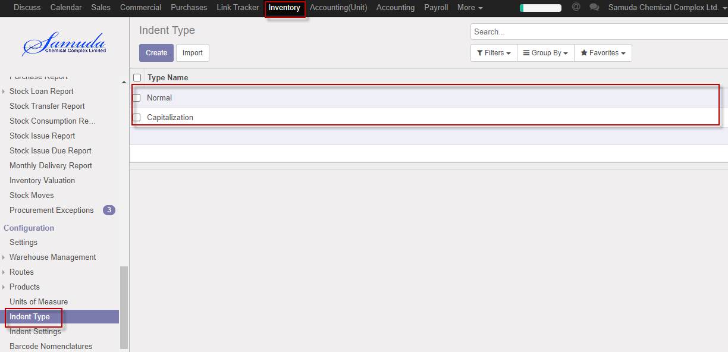

Figure: Indent type List view

We need to set the following:-

**Type name**: Enter a type name.

After entering all information click **Save**.

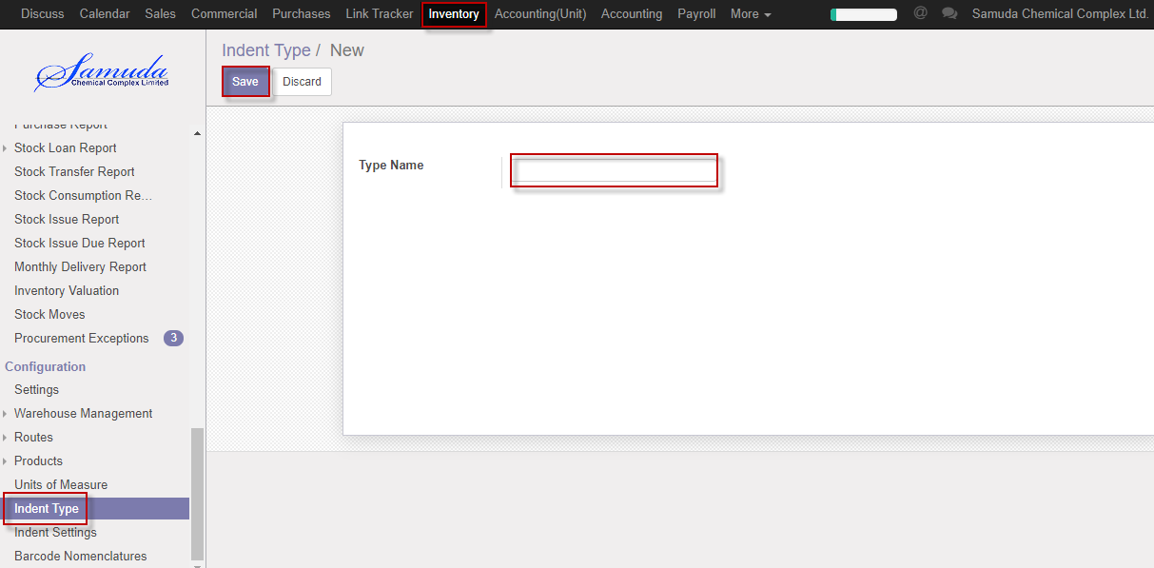

Figure: Create a Indent type

## 2.2 Create Warehouse by Inventory Manager

A **Warehouse** is the actual building/place in which your items are stocked. You can setup multiple warehouses and create moves between warehouses.

Inventory Manager can create Warehouse using the menu **Inventory ‣ Configuration-Warehouse Management ‣Warehouses** and click **Create.**

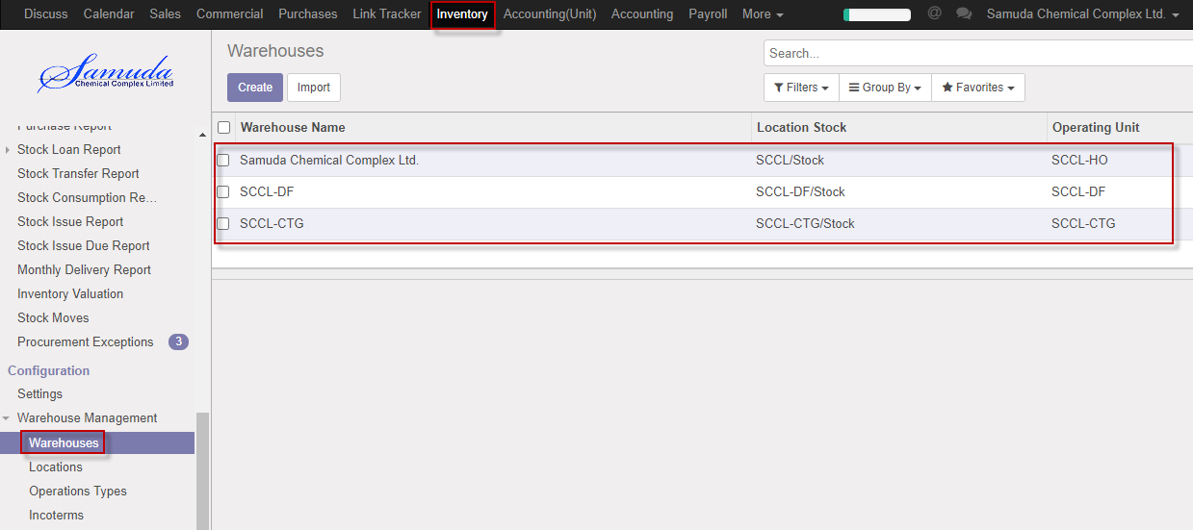

Figure: Warehouse List view

We need to set the following:-

**Warehouse name**: Enter a type name.

**Short name**: Enter a short name.

**Operating unit**: Select operating unit.

**Incoming Shipment**: Select an incoming shipment.

**Outgoing Shipment**: Select an Outgoing shipment.

After entering all information click **Save**.

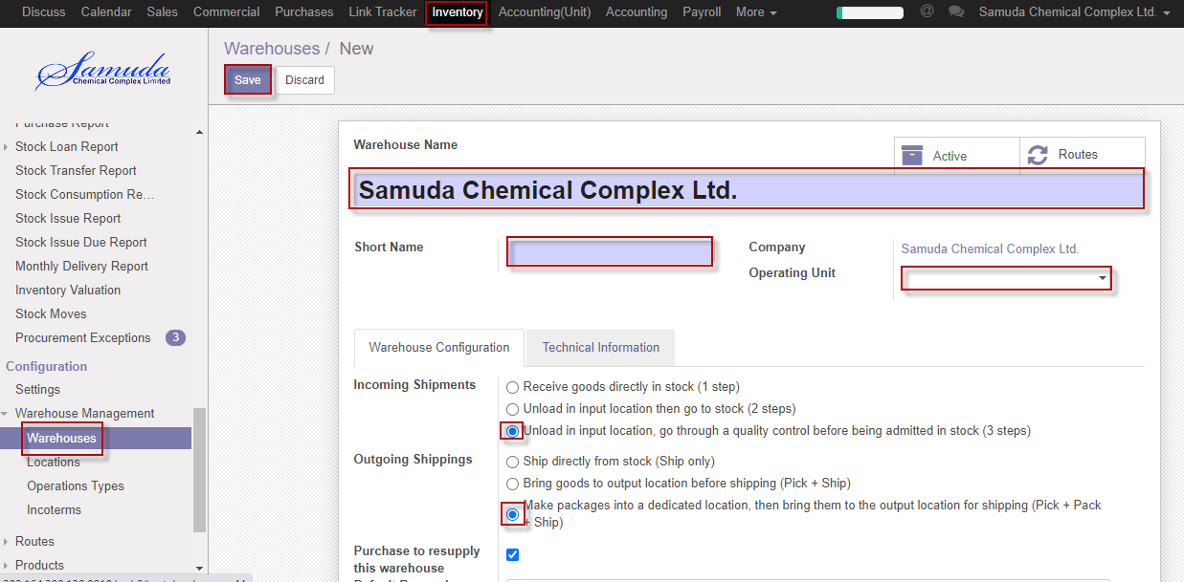

Figure: Create a Warehouse

## 2.3 Create Locations by Inventory Manager

A **Location**, is a specific space within your warehouse. It can be considered as a sub location of your warehouse, as a shelf, a floor, an aisle, etc. Therefore, a location is part of one warehouse only and it is not possible to link one location to multiple warehouses. You can configure as much locations as you need under one warehouse.

There are 3 types of locations:

* The **Physical Locations** are internal locations that are part of the warehouses for which you are the owner. They can be the loading and unloading area of your warehouse, a shelf or a department, etc.
* The **Partner Locations** are spaces within a customer and/or vendor's warehouse. They work the same way as Physical Locations with the only difference being that you are not the owner of the warehouse.
* The **Virtual Locations** are places that do not exist, but in which products can be placed when they are not physically in an inventory yet (or anymore). They come in handy when you want to place lost products out of your stock (in the **Inventory loss**), or when you want to take into account products that are on their way to your warehouse (**Procurements**).

Inventory Manager can create Location using the menu **Inventory ‣ Configuration >Warehouse Management >Locations** and click **Create.**

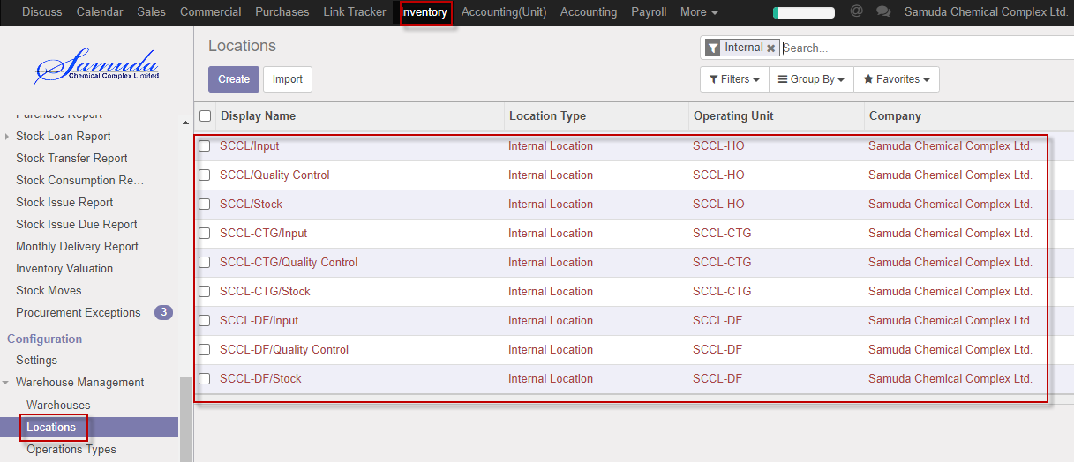

Figure: Location List view

We need to set the following:-

**Location name**: Enter a Location name.

**Location type**: Select location type.

**Company**: Select Company.

**Operating unit**: Select operating unit.

After entering all information click **Save**.

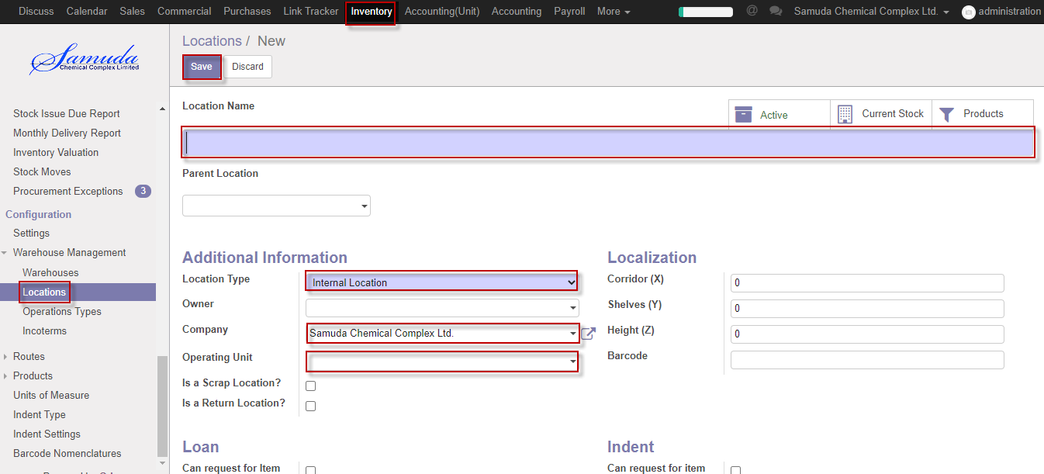

Figure: Create a Location

## 2.4 Create Operation type by Inventory Manager

Inventory Manager can create Operation type using the menu **Inventory ‣ Configuration –Warehouse management ‣Operation type** and click **Create.**

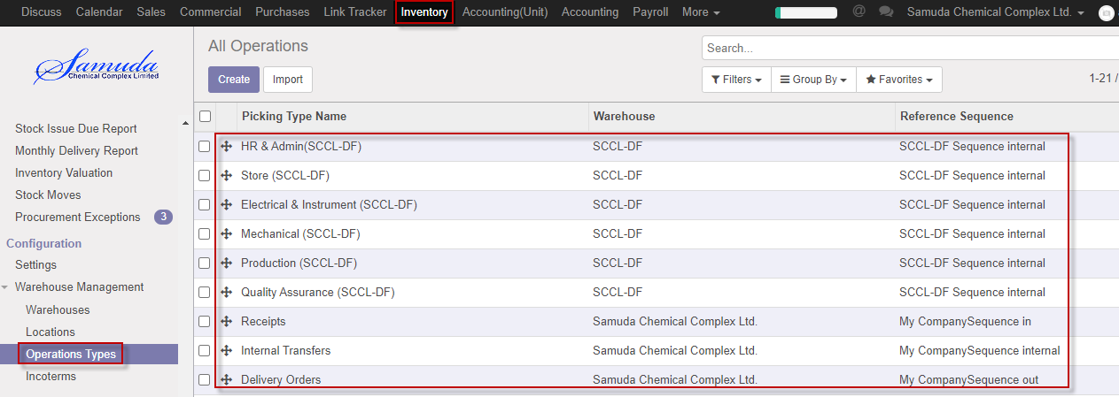

Figure: Operation type List view

We need to set the following:-

**Picking type name**: Enter a picking type name.

**Reference sequence**: Select reference sequence.

**Type of operation**: Select type of operation.

**Operating unit**: Select operating unit.

**Warehouse**: Select warehouse.

After entering all information click **Save**.

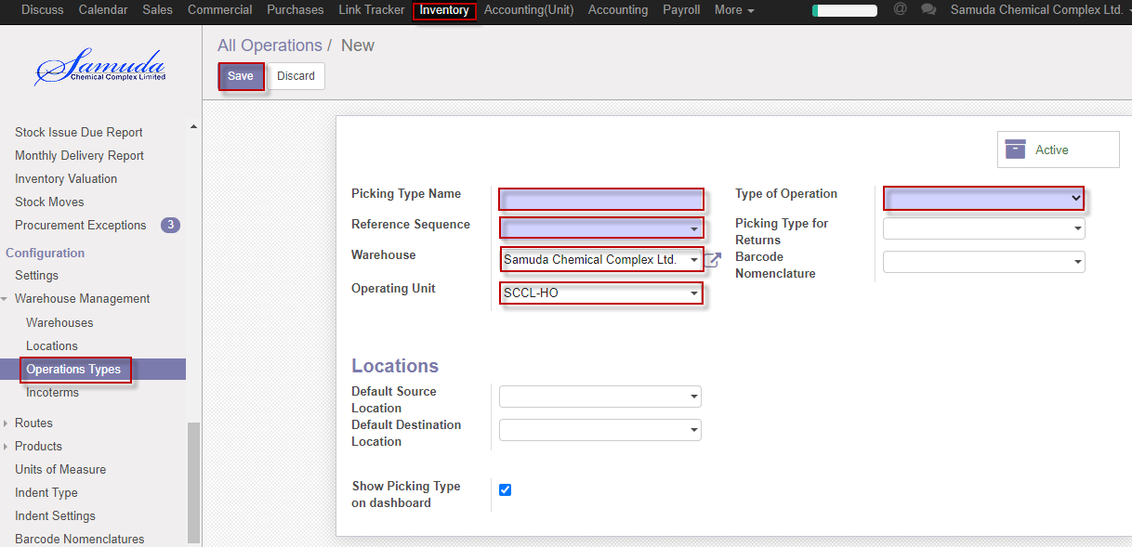

Figure: Create operation type

## 2.5 Create Unit of measure by Inventory Manager

Inventory Manager can create Unit of measure using the menu **Inventory ‣ Configuration‣ Product> Unit of measure** and click **Create.**

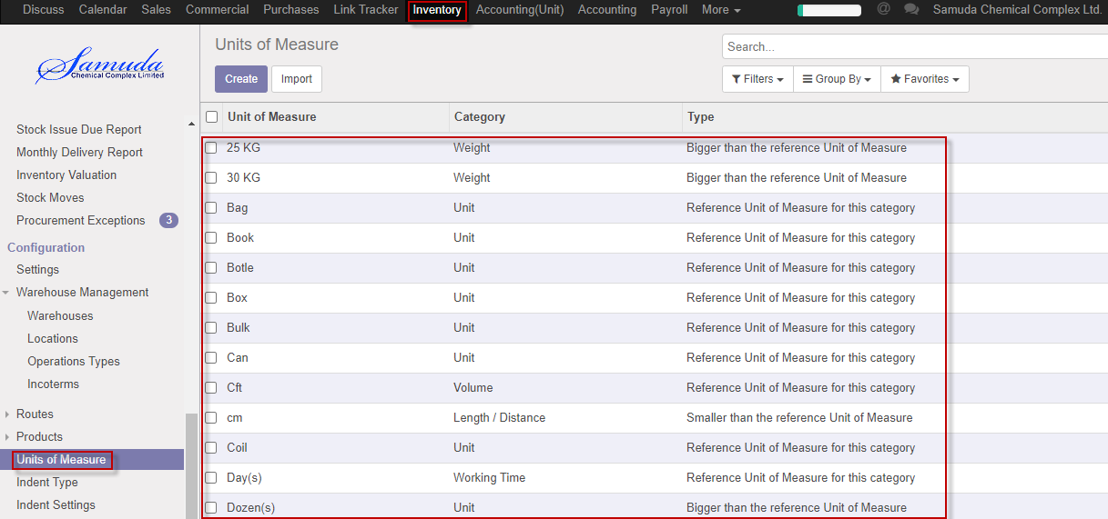

Figure: Unit of measure List view

We need to set the following:-

**Unit of measure name**: Enter Unit of measure name.

**Category**: Select category.

**Rounding precision**: Enter rounding precision.

**Type**: Select type.

After entering all information click **Save**.

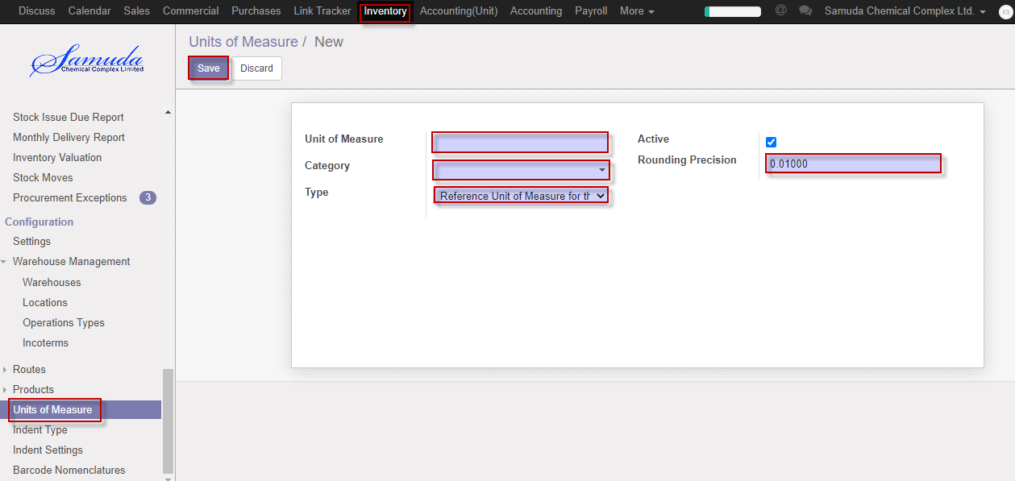

Figure: Create Unit of measure